## horizontal line

Types of Neural Networks (class2)

04.01.2025

# There are broadly 5 main types of Neural Networks .

## Artificial Neural Network

Used for supervised learning

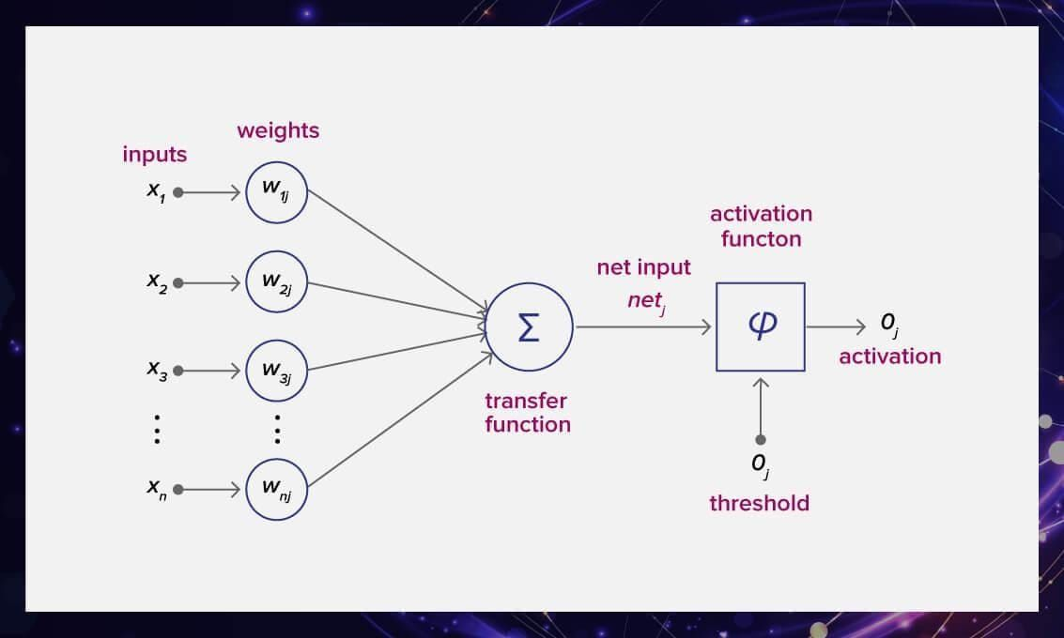

## Convolutional neural network

Image processing and video processing

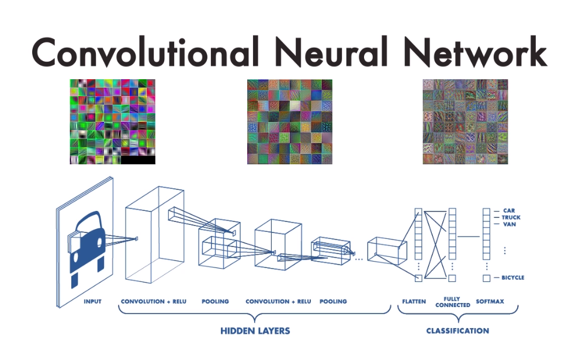

## Recurrent neural networks

NLPs

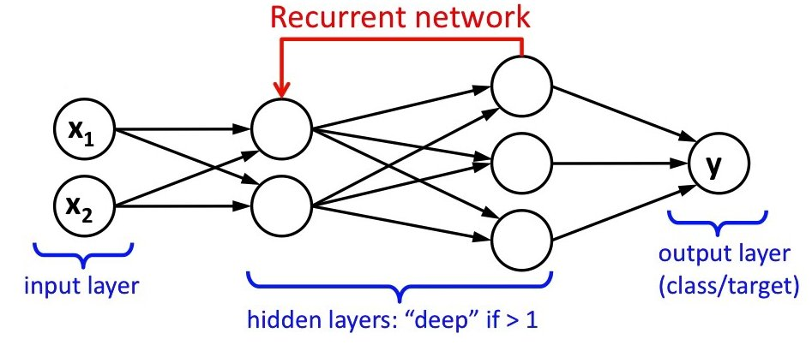

## Auto Encoders

Data compression without loss of quality .

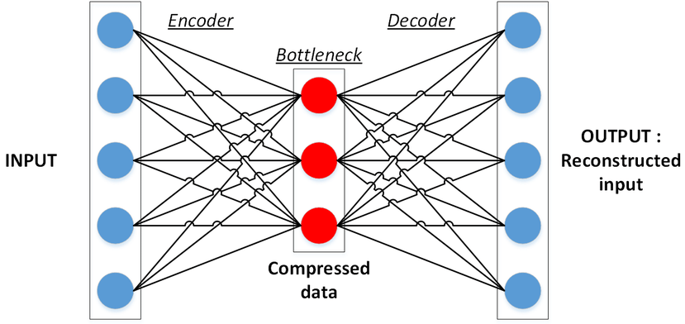

## Generative Adversarial Networks

Brings ANN to make imaginations .

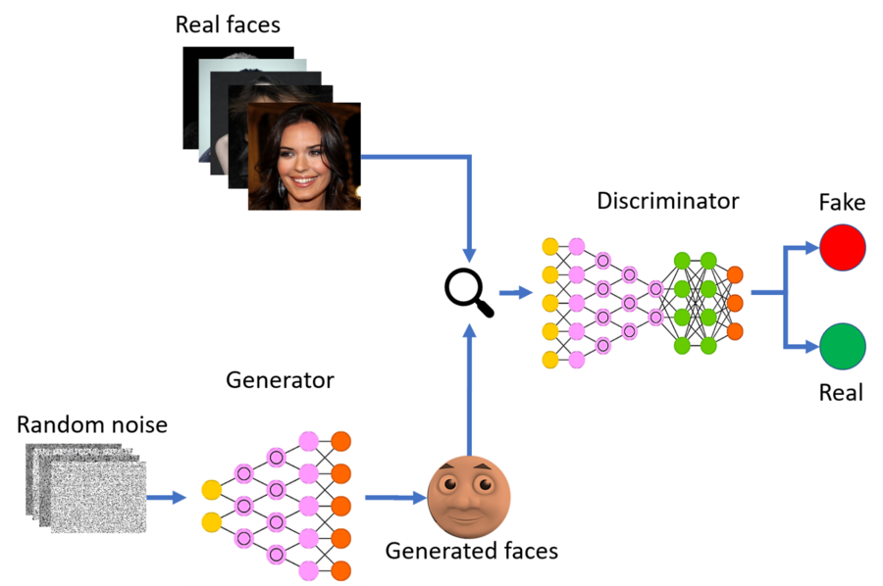

# History of Deep learning

1960’s - Frank Rosenblatt - discovered perceptron (inspired by human brain).

1969 - Marvin Minsky - First AI Winter (perceptron cannot learn XOR function or any non linear functions) .

1980’s - joph Hilton - The Rise (Learning representations using Backpropagation errors , Use Bunch of perceptrons to make hidden layers can converge nonlinear functions).

1989 - Yang - Use Zip codes

1980’s - Second AI Winter - no technique for initialization of weights , ML algorithms

Works well .

2006 - Unsupervised pre-Training .

2012 - The Final rise - Imagnet Challenge - Joph Hilton uses Deep learning on GPUs reduces errors to half . Thereafter DL goes on for research and developments.

# Applications of Deep Learning

1. Self Driving Cars
2. Game Playing Agents (AlphaGO)
3. Virtual Assistant (Siri , Cortana , Chatbots)
4. Image colorization
5. Pixel Restoration
6. Adding audio to mute videos
7. Image caption generation
8. Text translation
9. Object Detection (Google photos)
10. GAN